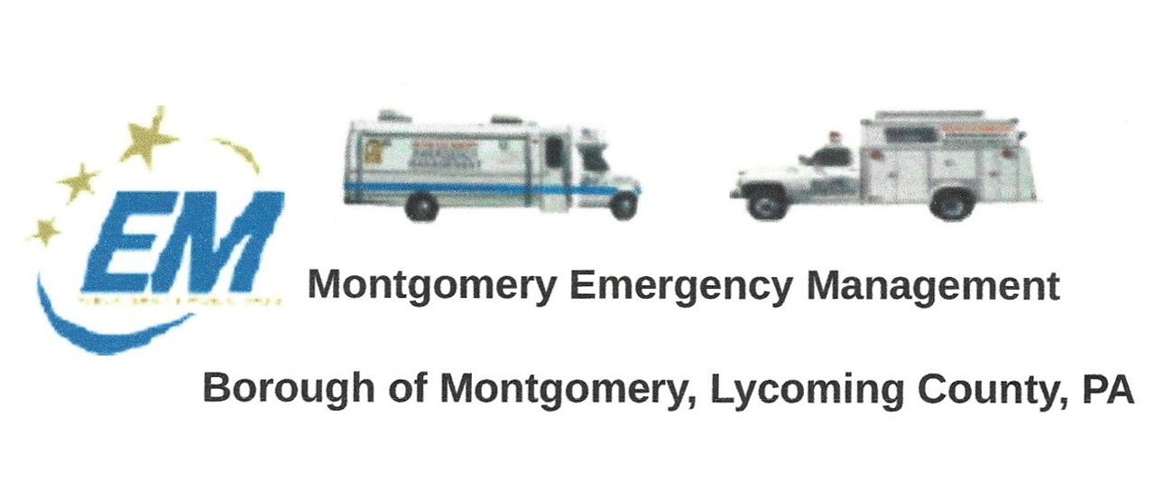

THE NEXT REGULAR MEETING OF THE MONTGOMERY BOROUGH EMERGENCY MANAGEMENT AGENCY WILL BE:
Greg Gruver, EMA Coordinator. 77 East Houston Avenue, Montgomery, PA 17752
Telephone: 570-547-1212 Cell: 570-419-4866 Email: monteman61@gmail.com
Fae Herb, Administrative Assistant. 102 Broad Street, Montgomery, PA 17752
Cell: 570-506-9892 Email: faeherb@aol.com
Meeting Room and Equipment Building: 40 Thomas Avenue, Montgomery, PA 17752
Borough EOC: 570-547-1671 Fire Hall EOC: 570-547-1381
INTERNET WEBSITE: www.montgomeryboroughema.org

THURSDAY, SEPTEMBER 8, 2022 AT 7 P.M.
REFRESHMENTS PROVIDED BY RYAN GROSS
Notes from Administrative Assistant, Fae Herb
Twenty-one years ago on Tuesday, September 11th at 8:45 the entire nation felt our lives change. It was at that day and time that the first Twin Tower in New York city was hit by a commercial airline that terrorists hijacked. Till the day ended, one more plane hit the second tower, another hit the Pentagon. Another hijacked plane, assumed to hit a target in Washington D.C. When passengers through phone call conversations were alerted to their possible fate, decided to fight back. Their patriotism, is honored and remembered each year with the 9/11 Memorial Motorcycle Ride that begins and ends at Clinton Township Volunteer Fire Company. EMA members man the Emergency Communications Van at the Fire Hall. Memorial Service will be at 2 p.m. with the 42 mile ride beginning shortly after.

EMA members also had the Communications Van at Montgomery Carnival Grounds to welcome Joe Snedeker, WNEP-TV weather meteorologist. An avid bicyclist, for the past 25 years he has done a charity bike ride for St. Josephs Center. This year the bike ride and telethon raised $1 million dollars ! Many local groups donated towards this cause.

Williamsport welcomed Little Leaguers from around the World. The first since 2019 that all Nations have been back to Williamsport. Members of the EMA took the Command Truck in the Little League Kickoff Parade held, Monday August 15th.

MAMA training is also back this year, scheduled for October 22-23. Scheduled to be held at 9 fire stations. It has been planned, but not confirmed that the EMA Command Truck would be stationed at Hughesville Fire Hall.

We send our sympathies to EMA member Wayne Simon on the loss of his wife, Judith, in August.

We welcome new members to join the Celebrated Montgomery Emergency Management Agency. A long history beginning in 1964, known then as Civil Defense and in later years renamed to Montgomery EMA. Volunteers are needed in all aspects, administration, fundraising and events as well as water rescue and other FEMA training activities. Monthly meetings are held every second Thursday of each month at the meeting room located at 40 Thomas Avenue, behind the maintenance garage at 7 p.m. Spread the word.

